APPLICATION FOR INCORPORATION SOCIETIES ACT CONSTITUTION

We hereby declare that we desire to have a society incorporated under the Societies Act of the Northwest Territories, and that

- THE NAME OF THE SOCIETY IS

- THE OBJECTS (OBJECTIVES) OF THE SOCIETY ARE

- The primary municipality of operations will be in

Name of primary (main) municipality

APPLICATION FOR INCORPORATION
SOCIETIES ACT
BYLAWS

THE FOLLOWING ARE THE BYLAWS OF

- Terms of Admission: All individuals are eligible for admission to membership in the Society on payment of the membership fee.

- Rights of Members: All members of the Society will have the right to take part in all activities and to use all facilities established by the Society for the promotion of its objects, subject to such regulations and the payment of such additional fees as the directors may from time to time prescribe for specific activities.

- Obligations of Members: Each member must pay an annual membership fee at such time and in such amount as is determined by the members at each annual general meeting. Members must uphold and adhere to the objects and bylaws of the society.

Withdrawal and Expulsion of Members:
  - Any member may withdraw from membership in the Society by submitting a notice, in writing, to the Secretary.

  - Any member whose conduct is considered detrimental to the Society or who is more than thirty days in default in paying annual dues may be expelled by a resolution passed by a majority of the directors of the Society.

Meetings:
  - Annual general meetings of the Society will be called and held between 31 and 180 days after the date of the society’s chosen fiscal year end;

  - Notice of any general or special meeting must be given at least seven days prior to the date set for the meeting. Notice is to be given by way of email, which address the member must provide to the Secretary; by the posting of notices of such meetings at conspicuous points throughout the area of operations; and/or by publication in a newspaper of general circulation; such notice to set forth the time, place and business to be transacted at such meeting;

  - General meetings of the Society are held at the call of the President;

  - Any ten members may call a special meeting by presenting a signed request to the President, who must call a meeting within fifteen days after receipt of such request;

  - Thirty (30)% of the paid up members constitutes a quorum at all meetings;

  - If the President or Vice-President is not present at a meeting, the meeting will elect a Chairman for the purposes of that meeting only;

  - Each member is entitled to one vote on any motion or resolution at all meetings.

Directors:
  - Until the first annual general meeting, the subscribers to the Application and Bylaws are the directors of the Society;

  - There must be between 3 and 12 directors elected from among the members of the Society at the first and each subsequent annual general meeting;

  - The directors may appoint chairpersons to head necessary committees, who are responsible to the directors and who will hold the designated offices until the next annual general meeting;

  - A majority of directors may appoint any member of the Society to fill a vacancy in their numbers and any director so appointed holds office for the unexpired portion of the term of the director he or she replaces;

  - The directors are responsible for conducting the affairs of the Society in accordance with its objects, its bylaws and with the Societies Act of the NWT;

  - A majority of directors will constitute a quorum at any director's meeting;

  - Any director may be expelled by a 2/3 majority vote of directors for proven dishonesty, or for gross misconduct, or for failing or refusing to carry out his or her duties as a director as provided in these Bylaws;

  - Directors or other officers will be paid travelling and living allowances to compensate them for expenses incurred by them in the conduct of their duties, and such other remuneration as is established by the members at the annual general meeting.

Officers:
  - The directors from their own number must, at their first meeting after incorporation and at their first meeting after the annual general meeting in each succeeding year, elect a

President, Vice-President, Secretary, Treasurer and such other officers as are deemed necessary;

  - Such officers hold office until the conclusion of each annual general meeting, at which time a meeting of the newly elected directors will be convened to elect their successors;

  - The President presides at all meetings of the members and of the directors. The President is responsible for the general management and supervision of the affairs and operations of the Society;

  - The Secretary will keep custody of the books and records of the society. The Secretary is responsible for providing notices of all meetings of members and all meetings of directors, and for taking and keeping record of the minutes of all such meetings;

  - The Treasurer is responsible for keeping full and accurate accounts of all receipts and disbursements of the Society;

  - The Vice-President is responsible for exercising the duties and powers of the President, Secretary and Treasurer in their respective absences;
  - The offices of Secretary and Treasurer may be combined into one office to be known as Secretary-Treasurer.

- Borrowing Powers: The directors may, by a 2/3 majority vote, borrow funds for capital expenditures and for the current operations of the Society in such manner as they see fit, including the issue of debentures; except that in no case may debentures be issued except pursuant to an extraordinary resolution.

Disposal of Funds:
  - All monies received by or on behalf of the Society must be deposited in the Society's bank account in trust for the Society, which account must be with one of the chartered banks of Canada;

  - All disbursements from the trust bank account must be made by cheques signed by the President or Vice-President, and the Treasurer, or in any of their absences, by some other director appointed by resolution of the directors.

10) Auditor: At the annual general meeting, the society may choose to elect an auditor for the ensuing year.

Annual Filings:
  - A notice of directors and a financial statement must be submitted to the Registrar of Societies each year, regardless of whether or not any changes have occurred, and regardless of whether or not the society has had any income.
- At each annual general meeting, an annual financial statement must be presented for the

inspection of members. The financial statement must either be endorsed by the auditor, or by the original signatures of two directors if there is no auditor. Statements must always
be prepared according to the society's fiscal year end; the first statement must begin on the Society's date of incorporation, and in subsequent years, must begin on the date which follows the previous year's fiscal end. The financial statement must always:
  - include the assets and liabilities of the Society, presented in the form of a balance sheet;

  - include the income/receipts (any received money) and expenses/disbursements (any paid-out money) of the Society, presented in the form of an income statement;

c) A notice of directors, originally signed by one director, must be submitted with the financial statement; the notice must include the time period and the names, addresses, and occupations of the directors of the Society.

Seal and Signing Authority:
  - If using a seal, the seal of the Society must include the name of the society in a circle around the word "SEAL".

  - The seal must be kept in the custody of the Secretary and may not be affixed to any instrument or document except by authority of a resolution of the directors, and in the presence of the Secretary and at least one other director;

  - The Secretary and at least one other director have the authority to sign instruments or documents on behalf of the Society.

- Inspection of Books and Records: All books and records of the Society must be open to the inspection of the members at each annual general meeting.

- Fiscal Year: The fiscal year of the Society ends on

the of of each year. (day) (month)
- Distribution of Assets: The Society may not distribute any part of its income to any of its members. This does not preclude the payment of reasonable salaries or employee benefits, nor does it preclude the reimbursement of reasonable out-of-pocket expenses. On a winding-up of the Society, all remaining assets must be distributed among Canadian charities registered pursuant to the Income Tax Act.

- Arbitration: Any dispute arising in the circumstances set out in section 7 of the Societies Act must be decided by arbitration under the Arbitration Act.

- In witness whereof we have subscribed our names to this application, consisting of the
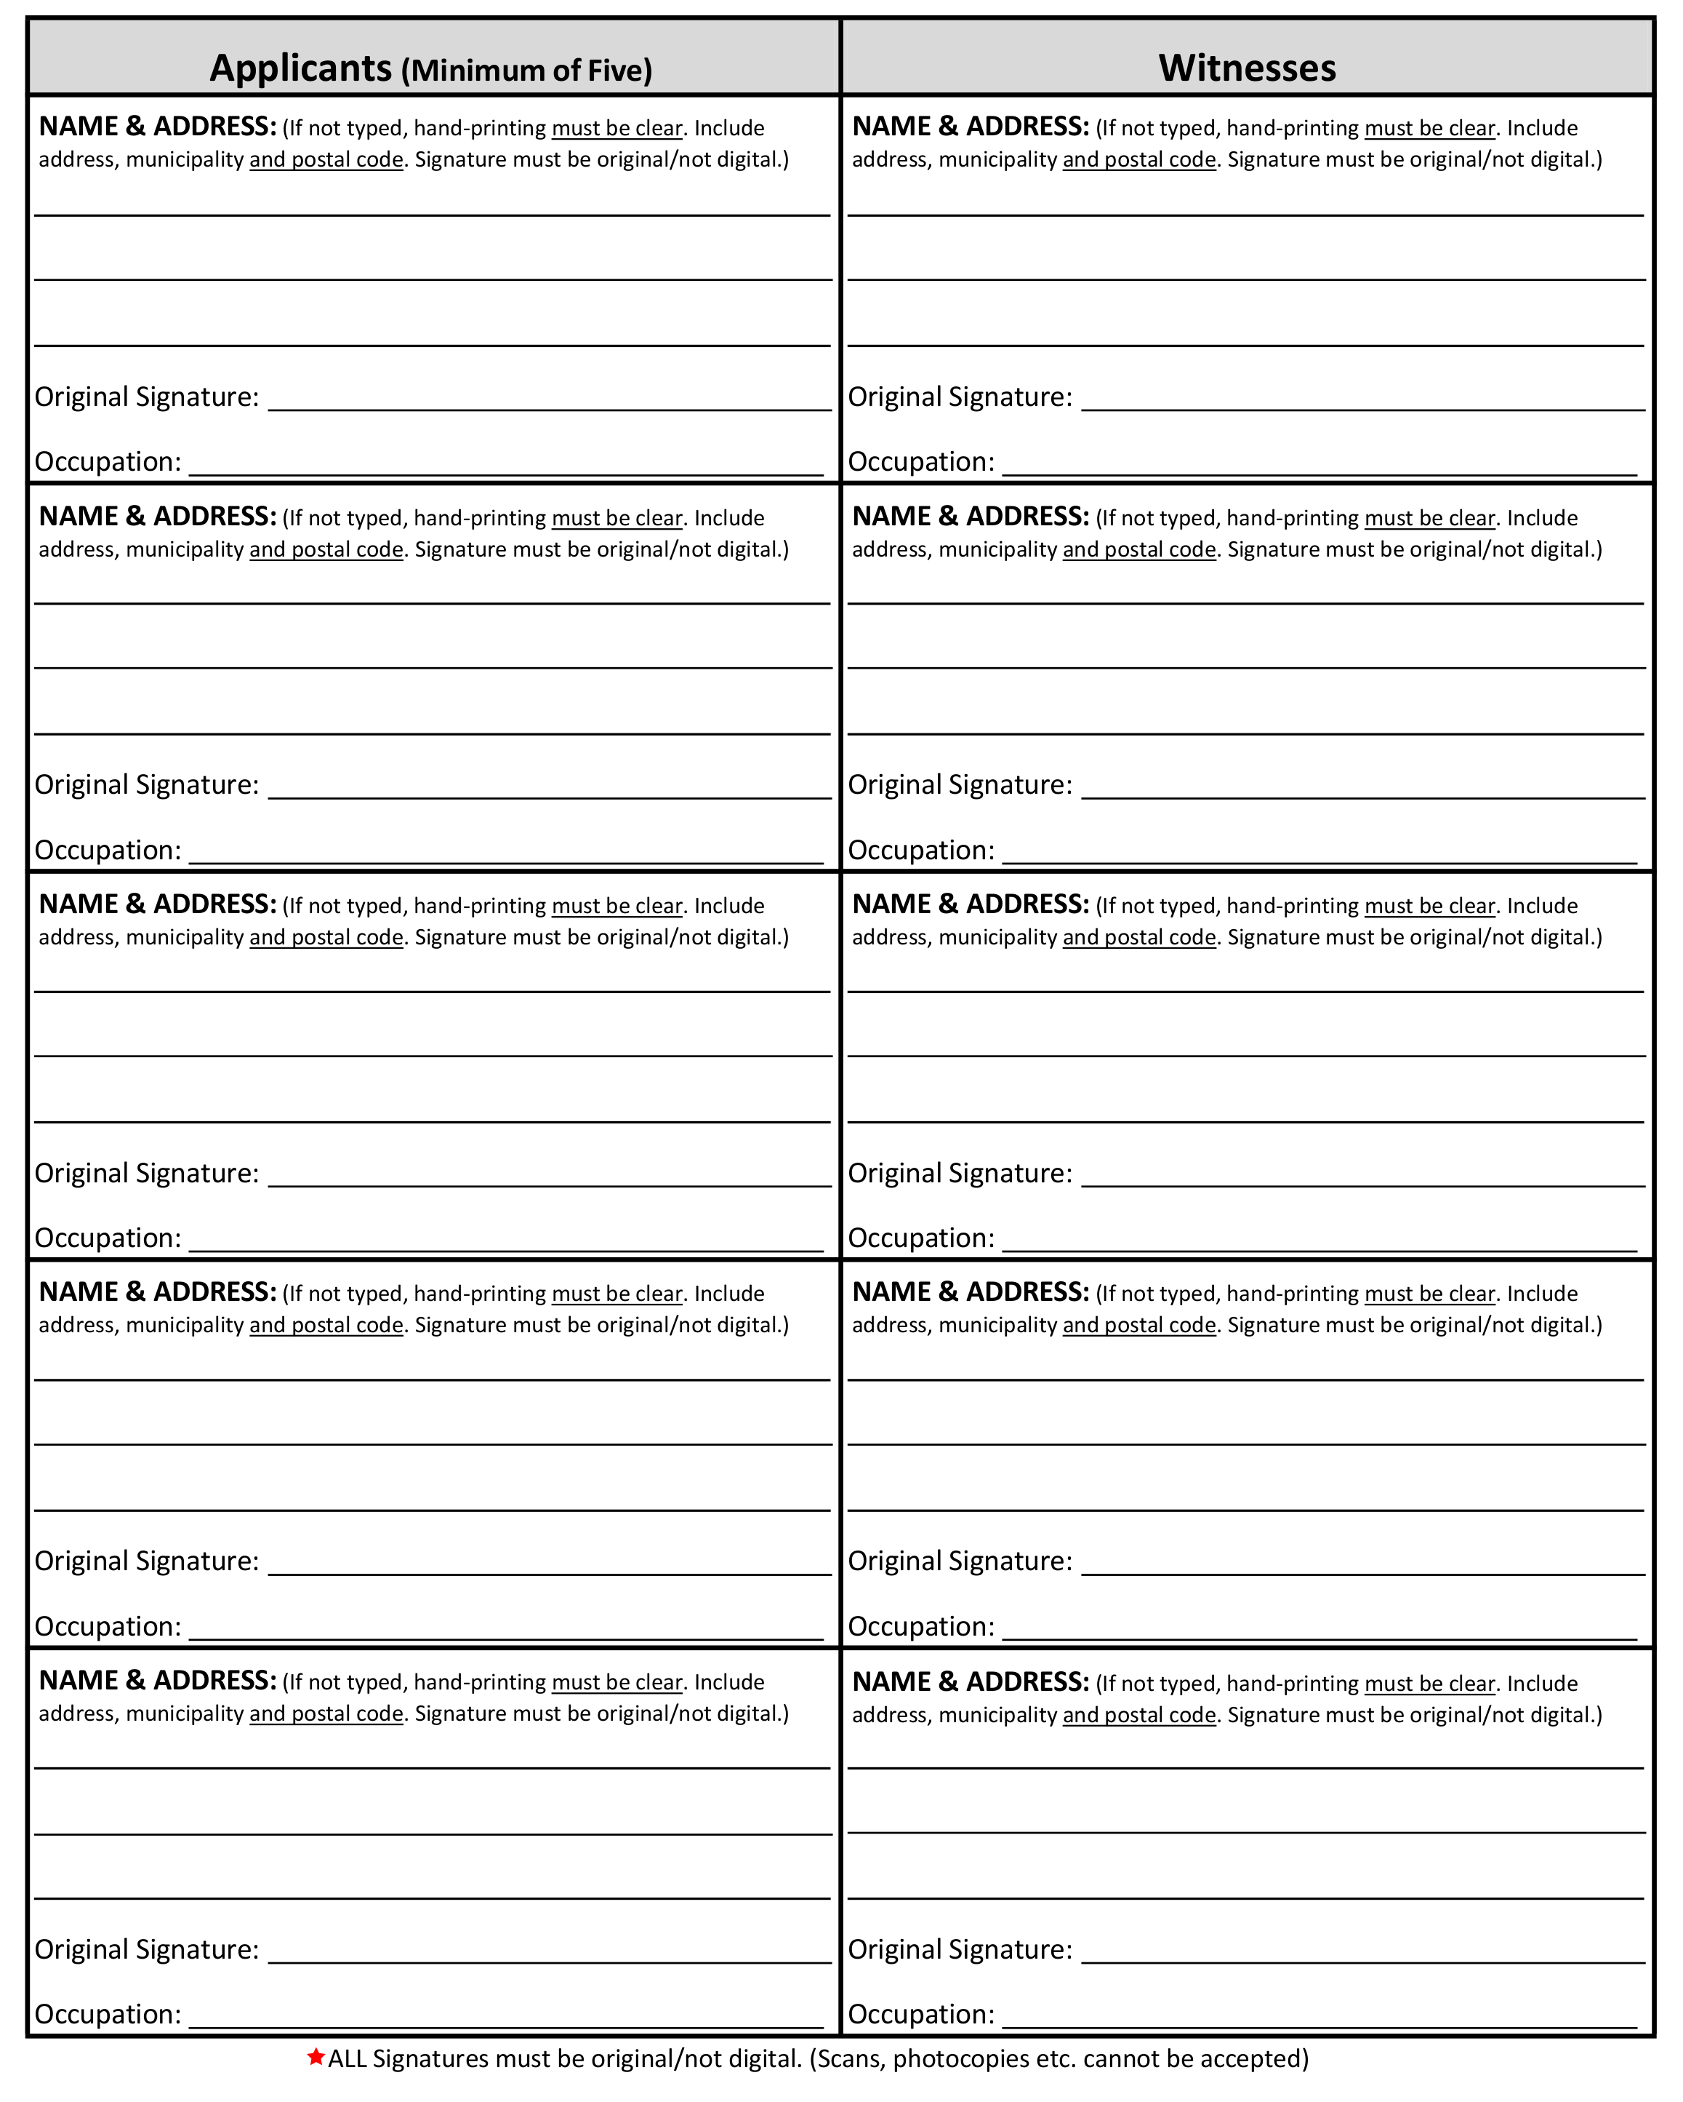
constitution and bylaws of the society, this day of _, 20_

APPLICATION FOR INCORPORATION
SOCIETIES ACT
NOTICE OF SOCIETY ADDRESS

- THE NAME OF THE SOCIETY IS

- The postal and street address of the Society (to which all communications and notices may be sent, and at which all processes may be served) within the Northwest Territories is:
Street address/ PO Box Municipality Territory (NWT) Postal Code
NORTHWEST TERRITORIES

⬇Forms with original signatures must be submitted.
(Scans, photocopies etc. cannot be accepted)

per: _______________________________________________ title: ___________________________________
(original signature) (Director or Officer)

dated this ____________ day of ____________________, 20__________.

