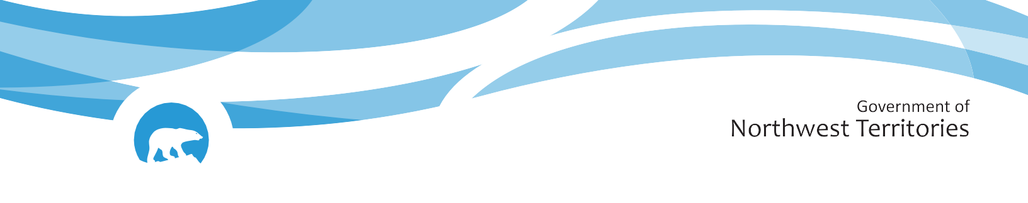

Public Safety Legislation

Civil Forfeiture and Safer Communities and Neighbourhoods (SCAN)
Background Document to Support Public Engagement

Communities in the Northwest Territories (NWT) are facing an increase in drug-related deaths and crime associated with the drug trade. Residents are worried about the level of illicit drug use and violent offences occurring in the NWT.
In response, the 20th Legislative Assembly has set a priority of promoting the safety of residents and communities and committed to develop public safety legislation so the government can better address communities’ safety concerns, protect property, shut down drug houses, seize assets from traffickers, and deter crime.
The GNWT is drafting new laws on Civil Forfeiture and Safer Communities and Neighbourhoods (SCAN).
The GNWT is now inviting the public to provide feedback in a number of ways:
In-person public meetings in Fort Smith, Hay
River, Norman Wells, Inuvik and Yellowknife;
- Virtual (online) meetings in English and French for those unable to attend in-person meetings or who live in other communities;
- An online survey which will be open to everyone in NWT; and
- An opportunity to provide written feedback that can be sent to HaveYourSayDOJ@gov.nt.ca.

This document provides more details on the proposed laws and can be used to help residents provide feedback on the proposals, ask questions and share their thoughts on how these proposals can contribute to increased community safety.
The document is split into two sections, one for each piece of legislation that is being proposed.

Civil Forfeiture Legislation

The Civil Forfeiture Act will allow the GNWT to apply for a court order to freeze and forfeit property where there is evidence the property was gained from, or used to carry out, a crime that is profit-motivated, likely to be used to commit crimes or result in bodily injury.
Property includes real and personal property like, cash, vehicles, real estate, jewelry, and other valuables.
The purpose of this Act is to take the profit out of crime and to deter individuals from committing more crime.

Key elements of Civil Forfeiture

The legislation will include the following:
- Any forfeited cash or any funds generated through the sale of forfeited property could be put towards compensating and supporting victims, supporting community programs and crime prevention initiatives to make communities safer. The GNWT would also be able to recover costs and expenses that the GNWT incurs from civil forfeiture.
- In certain cases, the GNWT could seek forfeiture of cash or other personal property through an administrative process. In these cases, a court hearing is not required unless the owner(s) of the property challenge civil forfeiture.
- In the event that the owner(s) of the property oppose civil forfeiture, they and the GNWT representatives would attend a court hearing. GNWT must give notice of these proceedings, and the process that will be followed will be described in the Act.
- If the judge finds the property was gained from criminal activity, or used to carry out a crime, the judge can order that the property be:
  - Returned to a person who has proven they were not involved in the crime or didn’t know their property was gained from or used to commit a crime;
  - Returned to the victim of the crime;
  - Sold, with the proceeds of sale being used to compensate victims of crime or creditors; or
  - Forfeited to the GNWT, to be used to support community programs and crime prevention initiatives, and recover costs and expenses related to the proceeding.
- The law will include measures to promote a transparent civil forfeiture program, like an annual report with updates on the civil forfeiture program’s activities.

Safer Communities and Neighbourhoods (SCAN) Legislation
The SCAN Act will give NWT residents the tools to take back their communities by allowing them to report problem residences that are continuously used for illegal activities and will give the Department of Justice the power to investigate and take action.
Unlike criminal investigations or filing criminal charges, which fall under federal laws and are the responsibility of the RCMP in the NWT, SCAN is a civil law, which means the GNWT can use non-criminal avenues to disrupt illegal activities in NWT residences.
Below is a description of what the SCAN Act and SCAN officers can do to end illegal activities in the NWT.
Key elements of SCAN
The Act will include the following:
- Types of Properties and Illegal Activity: SCAN applies to residential properties that are regularly being used for illegal activity such as drug trafficking, prostitution, bootlegging, or gang activity.
- Complaint Process: Any member of the public can submit a complaint. The complaint will be confidential, the details of the person will not be shared at any time during the process, to ensure that there is no intimidation, or threats.
- SCAN Officers and Powers: Specially-trained officers will openly investigate complaints made to them, dismiss complaints found to be unsubstantiated, resolve complaints informally or by agreement where possible, and assist landlords to apply to the Rental Officer for orders to end the illegal activities at a property that negatively affect the neighborhood or community. SCAN officers will also have the power to investigate and apply to the Rental Officer for an order regarding a property at their own initiative, for example, so the landlord doesn’t have to deal with the problem tenant or without having received a complaint, for example, if a person is known to have moved illegal activities from one house to another.
- SCAN Unit Roles: The SCAN Unit will work to ensure landlords are informed about and helped to prepare the necessary paperwork for Rental Office applications and hearings to avoid any unnecessary delays within required timelines and to protect public safety while allowing tenants to respond or vacate. The independent Rental Officers will review and make decisions on SCAN applications as per the legislated requirements.
- Responsibilities to Vulnerable Persons: When dealing with a SCAN complaint in a community, SCAN officers will investigate in the community and act as a resource to residents who have any concerns or information. When Rental Office orders affect uninvolved or at-risk occupants, SCAN officers will coordinate with housing and social services to minimize harm.
- Making best use of limited government resources: A made-in-the-NWT approach will ensure SCAN officers support real change that works in NWT communities and using existing resources like the Rental Office. SCAN officers will be on the ground to investigate and address concerns, and work with the RCMP to ensure public safety.
- Accountability & Reporting: The legislation will detail the types of reports that will be produced annually on total number of complaints received, investigations conducted, and outcomes, ensuring transparency, public confidence, and ongoing review of community impact.

